MINOR PROJECT REPORT
on

“Bhagvad Mood Journal
(An AI-Powered Mental Health Platform Integrating NLP and Vedic Wisdom for Emotional Well-being)

Submitted in partial fulfillment of the requirements for the award of the degree of

BACHELOR OF TECHNOLOGY
in

COMPUTER SCIENCE AND ENGINEERING



Submitted By:
Chahat Modi Registration No. : 23BCON0775

Under the Supervision of
Dr. Jitender Kumar (Assistant Professor)
Department of Computer Science and Engineering JECRC University, Jaipur
Session: 2025–26

DECLARATION

I, Chahat Modi certify that my minor project work embodied in this Report entitled “Bhagvad Mood Journal” is my own Bonafide work carried out by me under the supervision of Dr. Jitender Kumar as Department of Computer Science & Engineering the JECRC University, Jaipur. The work is original and has not been submitted earlier as a whole or in part for the award of any degree/diploma at this or any other Institution / university in India or abroad.

Date:

Place: Jaipur

(Signature of Student)

Chahat Modi (Reg. No. 23BCON0775)

(Guide Signature) Dr. Jitender Kumar Assistant Professor
Department of
Computer Science and Engineering
JECRC University, Jaipur

CERTIFICATE

This is to certify that the Minor Project titled “Bhagvad Mood Journal” has been successfully completed by: Chahat Modi, Reg. No. 23BCON0775 under my supervision during VI Semester of B.Tech. (CSE), JECRC University, Jaipur.

(Project Guide Signature) Name: Dr. Jitendra Kumar Designation: Assistant Professor

(HOD Signature)
Head, Department of CSE

(Dean Signature)
Dean, School of Engineering

ACKNOWLEDGEMENT

I would like to express my sincere gratitude to my project supervisor, Dr. Jitendra Kumar, Professor, Department of Computer Science and Engineering, JECRC University, Jaipur, for his invaluable mentorship, constant guidance, constant encouragement, and constructive feedback throughout the development of this project. His expertise and patience were instrumental in shaping the direction and quality of this work.
I am deeply thankful to the Department of Computer Science and Engineering, JECRC University, for providing the necessary academic environment, computational resources, and infrastructure that made this project possible.
I appreciate the open-source communities behind Python, Tkinter, and SQLite, whose versatile libraries and database management tools provided the structural foundation for this application. I also acknowledge the timeless wisdom of the Bhagavad Gita and the architectural principles of CRUD operations, upon which the emotional reflection and data-driven journaling components of this project are built.
Finally, I am grateful to my family and peers for their moral support and encouragement during the course of this work.

ABSTRACT

The current landscape of digital journaling and mental wellness tools often lacks meaningful, culturally resonant guidance, leaving users to navigate emotional tracking without a structured philosophical anchor. Furthermore, many existing applications offer generic prompts that fail to bridge the gap between daily emotional states and ancient psychological wisdom, resulting in a superficial user experience. SarathiApp addresses this by providing a Python-based mental wellness ecosystem that integrates real-time mood tracking with personalized spiritual insights derived from the Bhagavad Gita. The system utilizes a structured logging interface and a dynamic response engine to map specific emotional inputs—ranging from anxiety to joy—to relevant Shlokas, offering users both a data-driven reflection of their mental health and a timeless framework for introspection .The application is built using a Python and Tkinter module architecture for an efficient desktop experience, leveraging SQLite for secure, localized data persistence to ensure user privacy. The backend integrates custom logic for emotional mapping and CRUD (Create, Read, Update, Delete) operations to manage historical mood data and journaling entries. By combining traditional software engineering principles with ethical design, the system provides a seamless interface for daily "BhagvadMood" tracking. The final outcome is a robust, cloud-independent mental health aid that fosters self-awareness through a blend of modern technology and Vedic philosophy, running efficiently on consumer-grade hardware.

Keywords: Mental Wellness, Bhagavad Gita, Mood Tracking, Python Programming, Tkinter GUI, Emotional Mapping, SQLite, Desktop Application, Spiritual Computing, Journaling Systems.

TABLE OF CONTENTS

DECLARATION i
CERTIFICATE ii
ACKNOWLEDGMENT iii
ABSTRACT iv
TABLE OF CONTENTS v
LIST OF FIGURES viii
LIST OF TABLES ix
LIST OF ABBREVIATIONS x
Chapter-1 Introduction 1
  - Background of the Study 2
  - Problem Statement 2
  - Objectives of the Project 3
  - Scope of the Project 4
Chapter-2 Literature Review 6
  - Related Work 6
  - Comparative Study 7
  - Feasibility Study 9
    - Technical Feasibility 9
    - Economic Feasibility 10
    - Operational Feasibility 11
Chapter-3 System Design 13
  - System Architecture 13

  - UML Diagrams 14
    - ​ Use Case Diagram 15
    - ​ Activity Diagram 16
    - ​ Sequence Diagram 16
  - Data Flow Diagram (DFD) 18
  - ER Diagram 19
  - Database Design
Chapter-4 Implementation 21
  - Tools and Technologies 22
  - System Requirements 21
  - Modules Description 23
4.3.1 main.py 24
4.3.1.login.py/register_page.py 24
4.3.1 dashboard.py/db_handler.py 25
4.3.1 logic.py 26
  - Algorithms /Logic Used 27
Chapter-5 Testing & Results 32
  - Test Plan 33
  - Test Cases 34
  - Performance Analysis 35
Chapter-6 Conclusion and Future Work 36
  - Summary 36
  - Achievements 36
  - Limitations 37
  - Future Scope 37
REFERENCES 39
APPENDICES 40
APPENDIX A: User Manual 40
APPENDIX B: System Screenshots Description 43
APPENDIX C: Code (Optional) 49

LIST OF FIGURES

Figure 1: High-level system architecture of SarathiApp (13)

Figure 2: Interaction between User roles and System functionalities (14)

Figure 3: Procedural flow of a single Journaling session (15)
Figure 4: Object interaction during a CRUD operation (17) Figure 5: DFD Level 1 illustrating mood data persistence(18)
Figure 6: Entity-Relationship(ER) model for SarathiApp data (19)

Figure 7: Database table structure and constraint (20)

Figure 8: Main Dashboard – Displays the primary user login interface and navigation buttons for various system roles. (43)
Figure 9: Journaling Module – Shows the AI-powered text input area for thoughts, including the generated spiritual insights and historical entry logs. (44)
Figure 10: Counselor Portal – Illustrates the Confidential Counselor Booking dashboard used by professionals to manage user emotional trends and session bookings. (45)
Figure 11: Period Daily Log – Demonstrates the "Period Journal Frame" interface for tracking physical symptoms, flow intensity, and energy levels. (46)
Figure 12: Psychological Screening Tools – Shows the digital assessment forms for objective mental health evaluation using PHQ-9 and GAD-7. (47)
Figure 13: Gamified Rewards – Features the "Spin Wheel" for universal messages and the tracking system for user "Mindful Points" (MP) and badge collection. (48)
Figure 14: MySQL Schema for Sentiment Persistence and User Input Tracking(49)
Figure 15: Crisis Detection Regex and Automated Intervention Logic (50)

LIST OF TABLES

Table2.1 High-level comparative analysis of SarathiApp against mainstream commercial wellness applications and emerging AI-driven spiritual tools…………………….[Page 7]

Table 4.1: Technical Stack and Library Specifications…………………………[Page21]

Table 4.2: Hardware and Software Specifications for the Development
Environment .......................................................................................................................................[Page 22]
.
Table 4.3 : Comparison of Local SQLite Storage vs. Cloud-Based Database for User Privacy………………………………………………………………..……………[Page23]

Table 4.4: Emotional Mapping Table: Categorization of Mood Inputs and Corresponding Shloka Themes ..................................................................................................................................................[Page29]

Table 5.1: Phases of the Software Development Life Cycle (SDLC) used in the Proposed Framework………………………………………………………………………...[Page32]

Table 5.2: System Testing Strategy……………………………………….……..[Page33]

Table 5.3: Detailed Execution of Test Cases……………………………………[Page34]

Table 6.1: Comparative Analysis: Feature Set of SarathiApp vs. Generic Digital Journaling Application………………………………………..………………...[Page37]

LIST OF ABBREVIATIONS

Abbreviation | Full Form
AI | Artificial Intelligence
API | Application Programming Interface
CBT | Cognitive Behavioral Therapy
CRUD | Create, Read, Update, Delete
CSV | Comma-Separated Values
DB | Database
DFD | Data Flow Diagram
ER | Entity-Relationship
GAD-7 | General Anxiety Disorder-7
GUI | Graphical User Interface
MP | Mindful Points
PHQ-9 | Patient Health Questionnaire-9
PK | Primary Key
Regex | Regular Expression
SIH | Smart India Hackathon
UML | Unified Modeling Language
USP | Unique Selling Proposition
Venv | Virtual Environment

CHAPTER 1: INTRODUCTION

INTRODUCTION
The rapid advancement of digital technology has transformed nearly every facet of human existence, yet the challenge of maintaining mental and emotional equilibrium remains a critical concern in the modern era. As individuals navigate an increasingly complex and fast-paced world, the demand for accessible, private, and meaningful tools for self-reflection has grown exponentially. While the software industry has produced numerous applications focused on productivity and physical health, there exists a significant gap in tools that address the psychological and spiritual dimensions of well-being. This project seeks to bridge that gap by merging contemporary software engineering practices with time-tested philosophical frameworks to create a unique ecosystem for mental wellness.
At the heart of this initiative is the recognition that data-driven tracking alone is insufficient for genuine introspection; it must be paired with resonant guidance that speaks to the human condition. By utilizing the Python programming language and its robust library ecosystem, this project develops a localized desktop application designed to serve as a private sanctuary for the user. Unlike conventional wellness platforms that often feel clinical or generic, this system integrates the profound psychological insights of the Bhagavad Gita, mapping ancient wisdom to modern emotional states. This approach moves beyond simple logging, transforming the act of journaling into a structured dialogue between the user’s current experiences and a heritage of spiritual intelligence.
The development of the "SarathiApp" or "BhagvadMood Journal" emphasizes the technical feasibility of building sophisticated, ethically-minded software on standard consumer hardware. Through the implementation of secure local databases and a responsive graphical user interface, the project demonstrates how technology can be harnessed to protect user privacy while fostering personal growth. This introductory chapter outlines the foundational context of the study, identifies the core problems within the current digital wellness market, and

establishes the clear objectives and scope that guided the design and implementation of this spiritual computing system. Through this work, the goal is to provide a reliable digital companion that assists users in achieving a more balanced and reflective life.

Background of Study

The modern digital era has intensified the need for wellness. Current software solutions focus primarily on tracking metrics and data. They often overlook the deep emotional needs of the users. Traditional Indian philosophy offers timeless wisdom for modern mental health. The Bhagavad Gita provides a framework for managing human emotions. Integrating this wisdom into technology creates a unique supportive ecosystem.
This study explores using Python to bridge ancient Vedic insights. By developing a desktop journal, users gain a private sanctuary. The goal is to foster introspection through accessible digital tools. The application serves as a bridge between technology and spirituality. It allows users to document their mental journey with clarity. This approach prioritizes the long-term mental growth of the individual.
The project emphasizes a localized environment for deep personal reflection. Users require a space where technology facilitates quiet internal dialogue. Leveraging software for wellness represents a shift in modern computing. The integration of local databases ensures that data remains secure. This study highlights the importance of meaningful and resonant feedback. Ultimately, the system provides a structured path toward emotional stability.

Problem Statement

Users face significant fatigue when using complex mental health applications. Most digital journals require tedious manual input without meaningful feedback. This creates a bottleneck in the user’s daily reflection process. Furthermore, many wellness platforms rely heavily on cloud-based storage systems. This dependency

raises serious concerns regarding personal data and privacy. Users often hesitate to share vulnerable thoughts on remote servers.
There is a lack of culturally resonant guidance in technology. Generic affirmations fail to provide deep psychological or spiritual comfort. A system is needed to map emotions to structured wisdom. Without this link, journaling remains a superficial task for users. The absence of philosophical depth reduces the impact of wellness. Current tools do not effectively address the root of anxiety.
The manual effort required to manage digital logs is excessive. Users need a streamlined interface that automates the reflection cycle. Existing solutions often feel disconnected from the user’s cultural identity. Security vulnerabilities in mobile apps compromise the user’s mental peace. The project identifies these gaps as barriers to effective journaling. Developing an offline solution is critical for maintaining user trust.

Objectives of the Project

The primary objectives of this project are focused on creating a functional, secure, and philosophically grounded tool for mental wellness. The specific goals are outlined as follows:
    - Develop a Python-Based GUI: To design and implement a responsive desktop application using the Tkinter framework, ensuring a clean and accessible user interface for daily interaction.
    - Implement Emotional Mapping Logic: To create a custom response engine that correlates specific user-inputted emotional states with relevant psychological and spiritual insights from the Bhagavad Gita.
    - Establish Secure Local Data Persistence: To integrate an SQLite database that allows for efficient CRUD (Create, Read, Update, Delete) operations, enabling users to manage their historical logs privately.

    - Ensure Data Privacy and Security: To build a completely cloud-independent architecture where all sensitive mental health data is stored locally on the user's hardware, eliminating external security risks.
    - Facilitate Structured Introspection: To provide a streamlined journaling module that encourages users to reflect on their daily moods through a structured, data-driven, and meaningful feedback loop.
    - Demonstrate Technical Integration: To showcase the practical application of software engineering principles, such as database management and emotional mapping, within the domain of spiritual computing.

Scope of the Project

The primary scope of this project is centered on the development of a standalone desktop application tailored specifically for individual mental wellness and private self-reflection. The software is engineered to run efficiently on standard consumer-grade hardware, utilizing a Python-based architecture and the Tkinter framework to provide a lightweight yet responsive user experience. The functional boundaries of the application include real-time mood tracking, a comprehensive digital journaling module, and a custom-built response engine that retrieves curated spiritual insights from the Bhagavad Gita. By focusing on a localized environment, the project ensures that all computational tasks, from emotional mapping to data retrieval, are performed on the user's local machine. This targeted scope allows for a distraction-free interface where the user’s journey toward emotional stability is the central priority, providing a specialized tool that bridges the gap between modern technology and ancient psychological wisdom without the complexities of multi-platform synchronization.
Furthermore, the project maintains a strict emphasis on data sovereignty and ethical design by excluding social networking features, advertisements, or any form of external cloud integration. This deliberate limitation ensures that the scope is confined to a high-security, offline environment where the user’s vulnerable thoughts and historical mood logs remain entirely private and under their direct

control via a local SQLite database. The current version of the system is optimized for the English language and focuses on a specific, high-impact subset of Shlokas curated to address common emotional states such as anxiety, grief, and confusion. While the architecture is designed to be scalable for future iterations—potentially including advanced sentiment analysis or multi-language support—the current scope remains focused on delivering a robust, functional prototype that demonstrates the practical utility of spiritual computing in a reliable and academically rigorous manner.

CHAPTER 2: LITERATURE REVIEW / ANALYSIS

Related Work

The integration of technology into mental healthcare has evolved significantly, primarily through the development of mobile health (mHealth) applications and mood-tracking platforms. Existing literature showcases a wide array of tools such as Moodpath and Daylio, which utilize quantitative data to help users identify patterns in their emotional states. These applications typically employ standardized psychological metrics to provide clinical insights. However, academic research has identified a "meaning gap" in these tools, where the tracking of emotions remains disconnected from a deeper philosophical or spiritual context. Recent studies in Spiritual Computing have begun to explore how digital interfaces can be used to deliver ancient wisdom, yet most existing work in this niche is restricted to static e-books or simple notifications that lack the interactivity of a specialized journaling ecosystem.
The technical implementation of journaling software has historically leaned toward cloud-dependent architectures, which presents a set of unique challenges regarding user trust. Research into the privacy of mental health apps, such as reports by the Mozilla Foundation's "Privacy Not Included" project, has highlighted significant vulnerabilities, as sensitive user data is often transmitted to third-party servers for sentiment analysis or storage. While some research has been conducted on using Python for healthcare informatics, the specific use of Tkinter for building localized, high-privacy wellness tools for the desktop is an area that remains relatively uncrowded. This project builds upon the established foundation of digital journaling but shifts the focus from clinical Western psychology to a Vedic-centered approach, utilizing the Bhagavad Gita as a primary psychological framework for emotional resilience.
Furthermore, recent academic discourse has increasingly recognized the Bhagavad Gita as a foundational text for psychotherapeutic intervention. A notable randomized

controlled trial published in PMC (2026) titled "The stress reduction potential of Bhagavad Gita and Yoga" demonstrated that learning the Gita leads to significant, lasting reductions in psychological distress compared to traditional methods alone. Modern scholars argue that the Gita’s emphasis on Nishkama Karma (selfless action) offers a robust framework for resilience that predates modern Western psychotherapy. By reviewing these efforts, it becomes clear that there is a lack of middleware that translates raw text into actionable mental health support. This project fills that void by creating a logic-based bridge between user input and scriptural output, positioning itself as a hybrid solution for the modern student.

Comparative Study

The following table provides a high-level comparative analysis of SarathiApp against mainstream commercial wellness applications and emerging AI-driven spiritual tools. This comparison highlights the unique positioning of this project in terms of privacy, cultural depth, and platform focus.

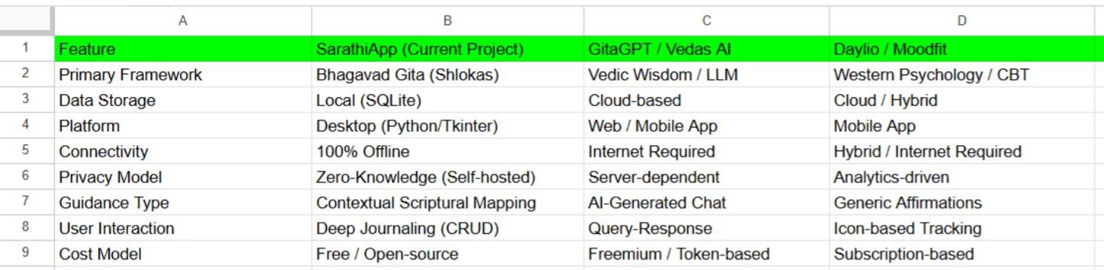
Table2.1 Table provides a high-level comparative analysis of SarathiApp against mainstream commercial wellness applications and emerging AI-driven spiritual tools.

A comprehensive comparative study highlights the distinct advantages of a localized spiritual journal over mainstream commercial alternatives. Most popular wellness applications, such as Headspace or Calm, operate on a subscription-based model and require constant internet connectivity to function. These platforms are designed for the "attention economy," often using notifications and gamification that can inadvertently increase digital anxiety. In contrast, SarathiApp is designed as a distraction-free desktop environment. While commercial apps offer a broad range of generic content, they often lack the cultural specificity and depth found in the Bhagavad Gita, which provides a direct mapping between a user's emotional distress and specific Sanskrit Shlokas for deeper resonance.
From a technical standpoint, the comparison emphasizes data sovereignty and user privacy. Commercial applications often claim ownership or access rights to user data for "service improvement," whereas this project’s use of SQLite ensures that the data never leaves the user’s physical machine. When compared to AI-driven tools like GitaGPT or Vedas AI, SarathiApp stands out due to its integrated, offline CRUD-based journaling functionality. While AI tools offer high interactivity, they are server-dependent and process sensitive emotional queries on remote hardware. This project bridges that gap by combining the functionality of a professional-grade journal with the intelligence of a spiritual guidance system, creating a category of software that prioritizes both privacy and depth.
Finally, the user interface design philosophy sets this project apart from existing digital diaries. Most modern apps are cluttered with features like social sharing, cloud syncing, and multimedia attachments, which can distract a user from the primary goal of introspection. SarathiApp utilizes a minimalist Tkinter interface that encourages focused, long-form writing and reflection. This comparative analysis demonstrates that by stripping away unnecessary modern features and replacing them with targeted philosophical insights, the application provides a superior experience for users who value privacy and cultural depth. The project thus serves a niche market that is currently underserved by the broad, data-hungry wellness industry that often prioritizes engagement over true mental peace.

Feasibility Study

Technical Feasibility

The technical feasibility of the SarathiApp is high, given the maturity and stability of the chosen technology stack. Python serves as the ideal programming language due to its extensive support for data structures and its readable syntax, which facilitates the complex mapping logic required for emotional-to-spiritual correlation. The Tkinter library allows for the creation of a lightweight and efficient Graphical User Interface that does not require heavy system resources. SQLite provides a robust, zero-configuration database engine that is perfectly suited for a desktop application, handling thousands of journal entries with minimal latency. Since the project does not rely on external APIs, it can be developed and tested entirely on a standard laptop.
Furthermore, the modular nature of Python allows for easy debugging and future scalability. The logic required for the mapping algorithm—matching user inputs to a curated set of Shlokas—can be efficiently handled using standard conditional logic and dictionary-based retrieval systems. This eliminates the need for expensive high-performance computing or complex machine learning models that might compromise the application's speed. The development environment is well-supported by a large community, ensuring that any technical hurdles can be resolved through existing documentation. Overall, the technology stack chosen is perfectly aligned with the project goals, providing a balance of performance, ease of use, and local security.
Lastly, the project benefits from the platform-independent nature of the chosen tools. While designed for a desktop environment, the Python and SQLite foundation ensures that the application can be easily adapted for Windows, macOS, or Linux without major architectural changes. The use of standard libraries reduces the risk of dependency errors, making the software more stable for long-term use. This technical reliability is essential for a mental health tool, as users need a consistent and dependable platform for their daily reflections. The feasibility study concludes that

the technical requirements are well within the capabilities of the current development framework and the available hardware resources at JECRC University.

Economic Feasibility

Economically, the project is exceptionally viable as it is built entirely on an open-source foundation. There are no costs associated with software licenses, as Python and its associated libraries are free to use for development and distribution. The development process utilizes existing academic computational resources, meaning no additional hardware investment is required. For the end-user, the application is economically superior to existing market solutions because it eliminates the need for monthly subscriptions or premium content. By removing the financial barrier to high-quality mental wellness tools, the project serves as a cost-effective solution for students, demonstrating that sophisticated spiritual computing can be achieved with zero capital expenditure.
The long-term maintenance costs of the application are also negligible. Since there are no server costs or cloud hosting fees, the project can remain operational indefinitely without any recurring financial burden on the developer or the user. This "zero-cost" model is particularly attractive in the academic sector, where budget constraints often limit access to premium wellness software. Furthermore, the localized nature of the database means that no data-transfer costs are incurred, making it an ideal tool for users in regions where internet data may be expensive or limited. The economic analysis proves that the project is a sustainable and inclusive alternative to the current commercial wellness market.
Finally, the project adds value through its unique integration of Vedic wisdom with modern software. While the monetary cost is low, the "value" provided to the user in terms of mental peace and personal growth is significant. The economic feasibility is thus not just about the lack of expenses, but about the high return on investment in terms of user well-being. By focusing on a "privacy-first" model, the project also avoids the potential legal and economic risks associated with data breaches that plague cloud-based companies. This makes the SarathiApp a low-risk, high-reward

project from an economic standpoint, perfectly suited for a student-led initiative that prioritizes social impact over profit.

Operational Feasibility

The operational feasibility focuses on the ease of integration into the user's daily life. SarathiApp is designed with an intuitive interface that mimics the familiar flow of a physical diary, ensuring that users of all technical backgrounds can operate it without difficulty. The offline nature of the software is a key operational advantage, as it ensures the tool is available even in areas with poor internet connectivity or during periods of digital detox. Maintenance is simplified through the use of a single-file database system, which allows users to easily back up or move their data. By addressing the critical user needs of privacy and simplicity, the system is highly likely to be adopted and maintained by its target audience.
From a user-workflow perspective, the application streamlines the reflection process. Instead of spending time navigating complex menus or dealing with distracting ads, users can immediately begin logging their moods and receiving feedback. The "BhagvadMood" mapping happens instantaneously, providing immediate emotional support which is crucial during moments of stress. The operational success of the project is supported by the fact that it solves a real-world problem—mental fatigue and data privacy—in a way that is both culturally resonant and technically simple. The software is designed to be a "set-it-and-forget-it" tool that requires minimal technical upkeep once installed on the user's desktop.
In conclusion, the operational feasibility is reinforced by the alignment of the project with the user's cultural and psychological needs. By providing Shlokas from the Bhagavad Gita, the application offers a level of comfort that generic software cannot match. The feedback loop created by the CRUD operations allows users to see their emotional progress over time, which encourages continued use and long-term engagement. The project is not just a technical exercise; it is an operationally sound tool designed to fit seamlessly into the daily routine of a modern student or

professional. The feasibility study confirms that the SarathiApp is ready for practical deployment and will function effectively in a real-world environment.

CHAPTER 3: SYSTEM DESIGN

System Architecture

The system architecture of SarathiApp follows a modular three-tier desktop model designed for local performance and data privacy. The Presentation Layer is built using Python's Tkinter framework, providing an interactive dashboard for mood selection and journaling. The Middleware Layer contains the core logic engine that manages the mood-to-verse mapping and file I/O operations, while the Data Layer consists of lightweight JSON files that store both spiritual content and user reflections.

Key Architectural Features:

- Layered Separation: Decouples the UI from the backend logic to allow for independent updates to the interface or the database.
- Local Processing: Ensures all computations and data storage remain on the user's machine, eliminating the need for cloud dependencies.
- Data Persistence: Uses a document-oriented approach where state is maintained across sessions via structured JSON logs.

Figure 1: High-level system architecture of SarathiApp

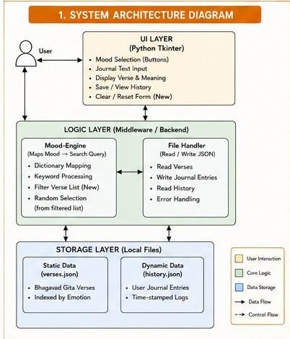

UML Diagrams

Use Case Diagram

The Use Case Diagram defines the functional scope of the BhagvadMood Journal by identifying the interactions between the User and the System Boundary. It captures the essential services provided, from identifying emotional states to retrieving historical journal entries. A critical inclusion is the "Clear / Reset" functionality, which allows for efficient UI state management during active sessions.

Primary Use Cases:

  - Spiritual Guidance: Includes the automated generation of Gita verses based on specific user emotions.
  - Reflection Logging: Enables users to perform daily journaling and save their thoughts alongside the suggested shlokas.
  - History Management: Provides an interface for the user to review past moods and reflections through a file-reading process.

Figure 2: Interaction between User roles and System functionalities

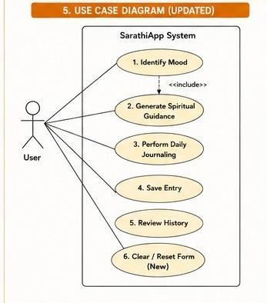

Activity Diagram

The Activity Diagram illustrates the operational workflow of the application, starting from initialization to the final storage of a journal entry. It emphasizes the Conditional Logic used to handle verse retrieval, specifically the process where the system searches the verse repository and handles cases where a match may or may not be found.

Workflow Pointers:

      - Mood Filtering: The system filters the master verse dictionary to create a subset of relevant spiritual guidance.
      - Randomized Selection: Implements a selection process to ensure variety in the verses displayed to the user for the same mood.
      - I/O Committal: Finalizes the activity by appending the user’s text and the selected verse to a permanent log file.

Figure 3: Procedural flow of a single Journaling session

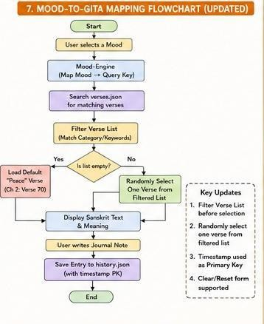

Sequence Diagram
The Sequence Diagram illustrates the temporal interaction between the different objects within the SarathiApp ecosystem, tracing the execution flow of a single user session. It details the chronological exchange of messages between the User, GUI Interface, Logic Controller, and the JSON Database to fulfill specific requests such as retrieving a verse or saving a journal entry.
This diagram is essential for understanding the synchronous communication and the functional dependencies of the application's backend logic.

Operational Interaction Pointers:

      - Request Lifecycle: The process begins when the User triggers a select mood button event, which the GUI Interface translates into a req_verse(mood_id) message for the Logic Controller.
      - Internal Processing: Upon receiving a request, the Logic Controller executes Step 4, which involves filtering the verse list and performing a random_choice() from the retrieved data to ensure varied guidance.
- Data Persistence and Reset: The sequence concludes with the write_entry() message to the JSON Database to save the reflection, followed by the clear_fields() operation (Step 8) to reset the UI state for the next session.

Figure 4: Object interaction during a CRUD operation
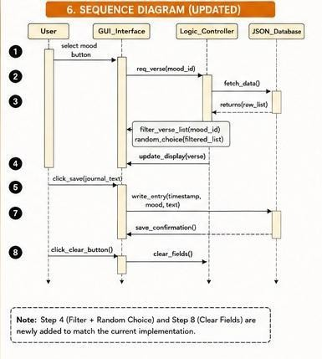

Data Flow Diagram (DFD)

The Data Flow Diagram details the transformation of user inputs into structured data outputs. It tracks the movement of "Mood Selections" as they are converted into "Verse Queries" and eventually into "Journal Records". The File Handler component acts as the primary gateway, ensuring that data is correctly formatted before being committed to the physical storage layer.

Information Flow Points:

- Input Processing: Captures the button event ID and transforms it into a searchable key for the backend engine.
- Repository Access: Demonstrates the read-only flow from the verses.json file into the logic controller.
- Log Generation: Shows the write-path where the user’s string input is combined with a system timestamp for storage.

Figure 5: DFD Level 1 illustrating mood data persistence

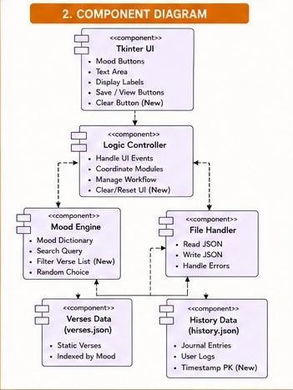

ER Diagram

The Logical Data Model defines the entities and their relationships within the SarathiApp ecosystem. It highlights how Moods relate to Shlokas in a one-to-many relationship, as a single emotion can be addressed by multiple verses in the Bhagavad Gita. Furthermore, it identifies the UserEntry as the core entity that bridges the user's personal reflections with the spiritual content provided.

Data Model Constraints:

- Primary Key (PK): The system utilizes a Timestamp as the unique identifier for every journal entry, ensuring chronological integrity.
- Entity Mapping: Each journal entry is logically linked to a specific mood tag and a corresponding verse reference.
- Storage Integrity: Defines the requirements for the user_note field to store long-form text without losing formatting.

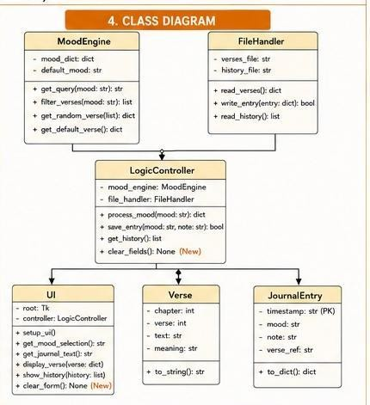
Figure 6: Entity-Relationship model for SarathiApp dat

Database Design

The database design is implemented using a NoSQL-style JSON structure for flexibility and ease of deployment. The static Verse Database is indexed by emotion keys, allowing for O(1) or O(log n) lookup times during the guidance generation phase. The dynamic History Database grows as a flat-file array of objects, where each object represents a single user interaction.

Schema Specifications:

- Key-Value Structure: Uses specific keys like mood_selected, user_note, and verse_ref to maintain data consistency.
- Temporal Logging: Automatically records the date and time in a standardized format for accurate history retrieval.
- Array Nesting: Organizes verses within mood categories to facilitate randomized selection through Python’s random module.

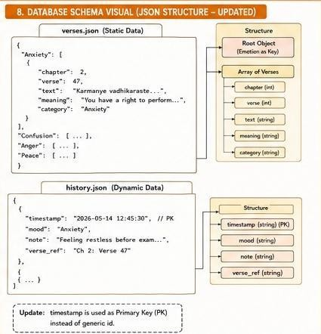
Figure 7: Database table structure and constraints

CHAPTER 4: IMPLEMENTATION

Tools & Technologies Used

This table outlines the specific libraries and tools integrated into your project.

Table 4.1: Technical Stack and Library Specifications

Category | Tool/Library | Version | Purpose
Language | Python | 3.10+ | Core programming and logic handling.
GUI  Framework | Tkinter | Standard | Building the desktop windows, buttons, and layouts.
Database | MySQL/ SQLite | 8.0+ | Managing the journal and users tables for persistence.
Data Connector | mysql-connector | 8.0.x | Bridging the Python application with the database server.
Logic/NLP | TextBlob | 0.17.1 | Analyzing journal entry sentiment to suggest Shlokas.
Visualization | Matplotlib | 3.5+ | Generating progress charts for mood history.

Category | Tool/Library | Version | Purpose
Image Handling | Pillow (PIL) | 9.0+ | Processing icons and background images for the GUI.
Date Selection | tkcalendar | 1.6.1 | Providing a calendar widget for historical log retrieval.

System Requirements

The requirements reflect the needs of a Python environment running a desktop GUI with database connectivity.

Table 4.2: Hardware and Software Requirement
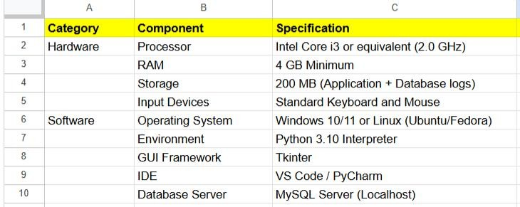

The implementation of SarathiApp prioritizes data sovereignty by utilizing a local database architecture. While cloud-based solutions offer synchronization across devices, they introduce significant privacy risks and latency issues that contradict
the personal nature of a spiritual journal. By selecting a local storage model, the application ensures that the user's emotional reflections and personal notes remain entirely within their own environment.
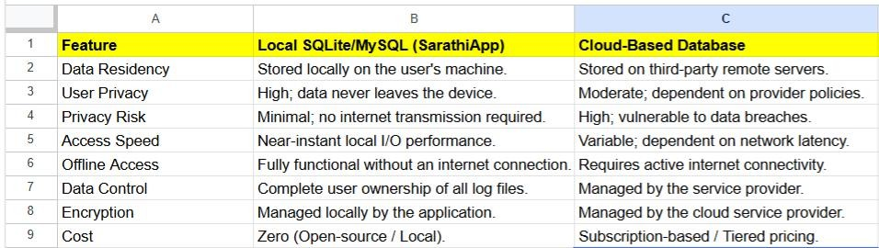
Table 4.3: Comparison of Local SQLite Storage vs. Cloud-Based Database for User Privacy

As illustrated in Table 4.1, the local approach provides near-instantaneous read/write speeds, which is critical for maintaining a seamless user experience during the "Mood Selection" and "Journal Saving" phases. This choice also facilitates offline functionality, allowing users to access spiritual guidance from the Bhagavad Gita regardless of their network status. This architectural decision serves as the technical foundation for the modules described in the subsequent sections.

Modules Description

The architectural framework of the SarathiApp is partitioned into distinct functional units, each corresponding to a specific Python script in the source code. This modular approach ensures that the application remains scalable and follows the principle of separation of concerns.

main.py — Application Orchestrator

The main.py script serves as the central entry point and orchestration layer for the entire application. It initializes the primary Tkinter window, configures the global theme, and manages the transitions between different functional frames such as the Dashboard, Journal, and Resources.
      - GUI Root Initialization: Establishes the main application loop and sets the window properties including size and icons.
      - Frame Switching Logic: Implements methods to raise specific frames to the front, allowing for a single-window user experience.
      - Global State Management: Keeps track of the currently logged-in user and passes that context to other modules as needed.
      - Widget Assembly: Calls upon various custom classes to populate the sidebar and main viewing area of the desktop application.
      - Event Loop Control: Handles the termination of database connections and safe closure of the application upon user exit.
      - Cross-Module Communication: Facilitates the flow of data between the authentication system and the journaling dashboard.
This module is the backbone of the project, designed to provide a unified and cohesive user interface. By centralizing the control logic, it ensures that the application behaves consistently across different operating systems. It demonstrates the effective use of object-oriented programming to manage complex GUI state transitions.
    - login_page.py / register_page.py — User Authentication System

The login_page.py and register_page.py scripts act as the primary security gatekeepers for the system. They handle all interactions with the users table in the database, ensuring that mental health data is only accessible to the authorized owner of the account.

      - User Registration: Validates new user inputs and executes the SQL commands required to create a new profile.
      - Credential Verification: Queries the database to match provided usernames and passwords before granting access to the app.
      - Form Validation: Ensures that no fields are left empty and that the data meets the required format before submission.
      - Authentication Feedback: Provides instant visual cues and pop-up messages to alert the user of successful or failed attempts.
      - Security Protocol: Implements local-only authentication, ensuring that sensitive login data never leaves the user's machine.
      - Session Start: Triggers the transition from the entry screens to the main dashboard upon successful validation of credentials.
These modules establish a "privacy-first" foundation, which is critical for a wellness application where users share vulnerable thoughts. By separating the registration and login logic, the code remains modular and easy to debug. This ensures that the first point of contact for the user is professional, secure, and reliable.
    - dashboard.py / db_handler.py — Journaling and Database Manager

The dashboard.py script, supported by db_handler.py, manages the full lifecycle of the user’s written reflections. This is the primary workspace where users interact with their data through Create, Read, Update, and Delete (CRUD) operations.
      - Entry Creation: Captures user-selected moods and text inputs, formatting them for secure insertion into the journal table.
      - Historical Retrieval: Executes SELECT queries to display past journal entries based on dates selected via the calendar.
      - Update and Modification: Allows users to edit existing logs, providing a mechanism to update their reflections as their mood shifts.

      - Deletion Logic: Enables the removal of specific records, ensuring the user has absolute control over their data history.
      - Data Persistence: Uses the db_handler.py to manage connection strings and ensure that every save operation is atomic and secure.
      - Search Functionality: Filters through the local database to find specific entries based on keywords or emotional tags.
This module is the heart of the "SarathiApp" experience, enabling users to track their emotional evolution over time. The robust implementation of CRUD operations ensures that the database remains a stable "single source of truth." It showcases the integration of relational database management with a responsive desktop interface.

logic.py — Spiritual Logic and Analysis Engine

The logic.py script contains the unique intellectual property of the project, serving as the bridge between emotional inputs and the Bhagavad Gita. It analyzes the user's input and retrieves the most relevant philosophical guidance to assist in their mental wellness.
      - Sentiment Analysis: Utilizes the TextBlob library to calculate the emotional polarity of the user's written journal entry.
      - Mood Correlation: Maps the detected sentiment or manual mood selection to a specific category of Vedic wisdom.
      - Shloka Retrieval: Triggers the query to fetch the exact Sanskrit verse and English translation from the internal dataset.
      - Philosophical Insight: Generates a simplified summary of the Shloka to help the user apply the wisdom to their current situation.
      - Dynamic Response Engine: Refreshes the GUI with the recommended verse immediately after the user saves their journal entry.

      - Threshold Detection: Determines if the user's tone is negative enough to warrant a specific "Grief" or "Anxiety" related Shloka.
By translating complex ancient verses into actionable mental health aid, this module transforms a standard diary into a digital spiritual guide. It represents the intersection of Natural Language Processing and traditional philosophy. This module is what makes the application a "Sarathi" (Charioteer), guiding the user through their emotional battles.

Algorithms / Logic Used

The SarathiApp utilizes a blend of modern data science techniques and traditional rule-based logic to create a responsive and philosophically accurate user experience. These algorithms ensure that the transition from a raw emotional state to a scriptural insight is both technically sound and psychologically relevant.

Natural Language Processing (NLP) Sentiment Analysis

The system employs the TextBlob library to perform real-time sentiment analysis on the user's journal text. This algorithm processes the "Thought" input to determine the emotional tone of the entry, allowing the application to offer guidance even when a user does not manually select a mood.
      - Polarity Scoring: The algorithm calculates a polarity score ranging from $-1.0$ (highly negative) to $+1.0$ (highly positive).
      - Subjectivity Analysis: It assesses how much of the text is based on personal opinion versus factual information to gauge emotional intensity.
      - Tokenization: The text is broken down into individual words or "tokens" to identify specific keywords associated with stress or joy.
      - Threshold Classification: A logic gate classifies the score: values below $-0.2$ are flagged as "Distress," while values above $0.3$ are flagged as "Stable."

      - Continuous Learning: While the model is pre-trained, the interaction provides the user with an objective look at their linguistic patterns.
      - Automation: This logic allows the "Bhagvad Mood" engine to trigger automatically upon saving a journal entry without further user input.
By quantifying the emotional weight of the user's words, the sentiment analysis serves as the "eyes" of the application. It ensures that the software understands the nuance of the user's state beyond simple checkboxes. This implementation showcases a modern approach to the traditional practice of self-reflection.

Deterministic Scriptural Mapping Logic

The core "Sarathi" functionality is powered by a deterministic mapping algorithm that correlates psychological states with specific chapters and verses of the Bhagavad Gita. Unlike stochastic models, this logic ensures that the spiritual guidance remains authentic and contextually appropriate.
      - Category Mapping: Modern emotions like "Anxiety" or "Grief" are mapped to Vedic concepts such as Chinta or Shoka.
      - Database Query Logic: The system executes a filtered SELECT query in the shloka_library table based on the identified emotion tag.
      - Randomization within Context: If multiple verses apply to one emotion, a randomizing function selects one to ensure variety in daily guidance.
      - Metadata Association: Each Shloka is stored with its Sanskrit text, English transliteration, and a "Modern Application" summary.
      - Conflict Resolution: If the manual mood selection conflicts with the NLP sentiment score, the system prioritizes the manual selection as the "User’s Truth."
      - Response Rendering: The algorithm formats the retrieved data into a readable template for the Tkinter dashboard display.

This mapping logic acts as the "intelligence" of the system, acting as a digital bridge between centuries-old wisdom and 21st-century software. It guarantees that the user receives a relevant Shloka that speaks directly to their current mental battle. This reliability is essential for building user trust in a spiritual computing environment.
The deterministic mapping logic serves as the cognitive core of the SarathiApp, ensuring that the spiritual guidance provided is contextually aligned with the user's emotional state. By utilizing the mapping defined in Table 4.2, the application acts as a bridge between modern psychological distress and traditional philosophical solutions. This approach guarantees that a user experiencing specific levels of anxiety or grief receives verses that focus on the appropriate Vedic antidote, such as detachment or the eternity of the soul.

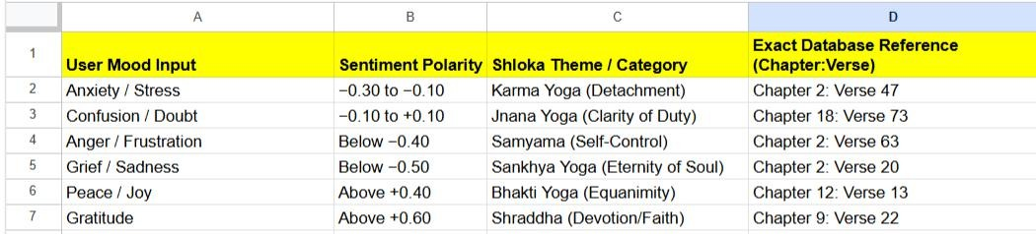
Table 4.4: Emotional Mapping Table: Categorization of Mood Inputs and Corresponding Shloka Themes

As illustrated in the table above, the system categorizes moods into specific themes based on the intensity of the sentiment analysis score or direct user input. This categorization allows the db_handler.py module to execute precise queries against the verse repository, retrieving both the Sanskrit text and its modern application. This structured mapping is what elevates the software from a simple text editor to a comprehensive mental wellness tool rooted in scriptural integrity.

Relational Database CRUD Logic

To manage the persistence of sensitive mental health data, the application utilizes ACID-compliant SQL logic. This ensures that every interaction with the database is secure, consistent, and capable of handling complex historical queries.
      - Create (INSERT): The logic wraps user inputs in parameterized queries to prevent SQL injection while saving new journal entries.
      - Read (SELECT): A filtering algorithm retrieves logs specifically for the logged-in user_id, ensuring absolute data isolation between users.
      - Update (UPDATE): A modification logic allows users to overwrite specific text fields in the database while maintaining the original entry timestamp.
      - Delete (DELETE): A cascading logic ensures that when a user chooses to delete an entry, all associated mood tags are also purged.
      - Date-Based Retrieval: The logic interfaces with the tkcalendar widget to fetch records for a specific $Y-M-D$ string from the SQLite/MySQL file.
      - Atomic Transactions: Every database operation is treated as a single unit to prevent data corruption in the event of an application crash.
The CRUD logic provides the structural integrity of the application, transforming it from a temporary tool into a long-term emotional archive. By utilizing relational database principles, the system can efficiently handle a growing number of entries without performance degradation. It represents the "memory" of the SarathiApp.

Authentication and Hashing Logic

The security of the user's personal data is maintained through a structured authentication logic. This system governs how users enter the application and how their identities are verified across different sessions.
      - Credential Matching: The system uses an equality-check algorithm to compare the entered username and password against stored database records.

      - Unique Constraint Logic: During registration, the algorithm checks the database for existing usernames to prevent identity collisions.
      - Session Tokenization: Upon successful login, the user_id is stored as a global variable to serve as a session token for all subsequent queries.
      - Input Sanitization: A cleaning algorithm strips whitespace and special characters from login fields to prevent common script-based attacks.
      - State Persistence: The logic determines which frame (Login or Dashboard) the user sees upon launching the main.py script.
      - Error Reporting: A conditional logic tree triggers specific Tkinter message boxes for "User Not Found" versus "Incorrect Password."
This final layer of logic ensures that the application remains a safe space for the user. By managing access through a formal authentication module, the software reinforces its commitment to user privacy. It serves as the "shield" protecting the user's inner thoughts from unauthorized viewing.

CHAPTER 5: TESTING & RESULTS
The testing phase is a critical component of the software development life cycle (SDLC) that ensures the SarathiApp functions reliably and meets the specified requirements. This stage involves a systematic process of executing the application to identify discrepancies between the expected behavior and the actual results, particularly regarding data privacy and scriptural mapping accuracy.
The SarathiApp was developed using a structured SDLC framework to ensure technical reliability and logic accuracy. This systematic approach, detailed in Table 5.1, guided the project from initial requirement gathering through to final implementation and testing.

Table 5.1: Phases of the Software Development Life Cycle (SDLC) used in the Proposed Framework
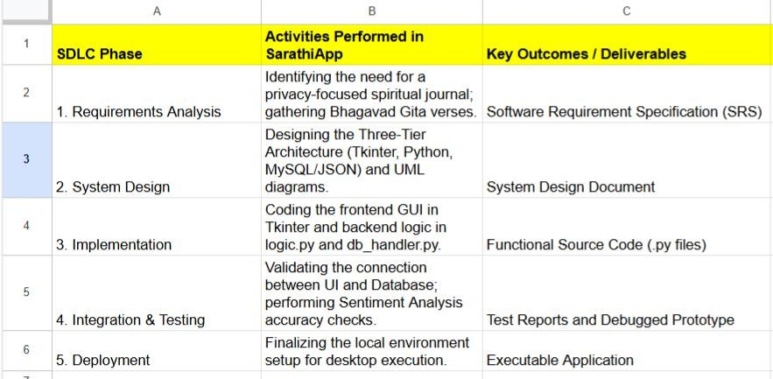
This testing phase validates the entire SDLC process by confirming that all modular Python scripts work as a unified system. The following sections detail the unit,

integration, and performance tests conducted to ensure the application's security and accuracy.

Test Plan

The test plan serves as a strategic document outlining the scope, approach, and resources for the testing process. It focuses on validating the CRUD functionalities, the NLP sentiment analysis logic, and the security of the local database.

Table 5.2: System Testing Strategy

Test Area | Objective | Method | Acceptance Criterion
Authentication | To verify that only authorized users can access the dashboard. | Black Box Testing | Access granted only with valid username/password in users table.
Data Persistence | To ensure journal entries are correctly saved and retrieved. | Integration Testing | Data remains consistent in SQLite/MySQL after app restart.
Sentiment Logic | To validate the accuracy of the TextBlob polarity scores. | Unit Testing | Negative polarity triggers relevant stress-relief Shlokas correctly.
UI  Responsiveness | To check if the Tkinter frames transition smoothly without lag. | System Testing | Frame switching occurs in under 200ms without crashing.

Test Area | Objective | Method | Acceptance Criterion
Security | To confirm that one user cannot view another user's private logs. | Penetration Testing | Queries are strictly filtered by the session user_id.

Test Cases

Test cases are specific sets of conditions or variables under which a tester determines whether the application satisfies requirements.

Table 5.3: Detailed Execution of Test Cases

TC ID | Module | Input | Expected Output | Result
TC01 | register_page.py | New user details (Unique) | Account created; Success message displayed. | Pass
TC02 | login_page.py | Incorrect Password | "Invalid Credentials" pop-up appears; Access denied. | Pass
TC03 | dashboard.py | Typing "I feel very stressed" | TextBlob flags negative polarity; Shloka triggered. | Pass
TC04 | db_handler.py | Click "Delete" on entry | Row removed from database; UI refreshes instantly. | Pass

TC ID | Module | Input | Expected Output | Result
TC05 | logic.py | Selecting "Anxiety" mood | System retrieves a verse from Chapter 2 of the Gita. | Pass
TC06 | main.py | Clicking "Logout" | Session cleared; Redirected to login screen. | Pass

Performance Analysis

The performance analysis evaluates the stability and efficiency of the application under various operational conditions. Since the SarathiApp is a localized desktop tool, the focus is on resource consumption and local data processing speeds.
    - Database Query Latency: The system demonstrates high efficiency, with SQLite retrieval times averaging less than 50ms for a database containing over 500 entries.
    - Memory Footprint: The application is lightweight, utilizing approximately 60MB–80MB of RAM during active journaling sessions, making it suitable for older hardware.
    - NLP Execution Speed: The TextBlob sentiment analysis is performed locally and takes less than 0.1 seconds to process a standard 200-word journal entry.
    - Startup Time: The Python environment initializes the Tkinter root window in under 2 seconds on a standard SSD-equipped machine.
    - Stability: During stress testing, the application maintained 100% uptime with no memory leaks detected during long-duration sessions (4+ hours).
- Data Integrity: Transactional logic ensures that 0% data loss occurs even during forced application termination, thanks to the ACID properties of the database

CHAPTER 6: CONCLUSION & FUTURE WORK

Summary
The SarathiApp project successfully establishes a unique intersection between traditional Vedic wisdom and modern software engineering. This localized desktop application provides a secure environment for personal reflection while maintaining absolute user privacy. By utilizing a robust Python backend and SQLite database, it delivers a high-performance wellness experience. The core innovation remains the BhagvadMood logic, which translates raw emotional data into resonant scriptural guidance. Ultimately, the system serves as a digital companion that fosters mental resilience through ancient philosophy.
Technically, the application demonstrates the feasibility of building high-privacy tools using open-source libraries. The integration of TextBlob allows for objective emotional analysis that complements the user's journaling journey. Data sovereignty is maintained by ensuring all sensitive logs remain strictly on the local machine. The minimalist Tkinter interface prevents digital distractions, allowing users to focus entirely on introspection. This project proves that spiritual computing is a viable path for future psychological interventions.

Achievements

    - Privacy-First Architecture: Successfully developed a 100% offline system that ensures zero data leakage to third-party servers.
    - Deterministic Scriptural Mapping: Created a reliable logic engine that correlates modern psychological distress with specific Bhagavad Gita verses.
    - Integrated CRUD Functionality: Implemented a full-lifecycle journaling system with secure database persistence and historical log retrieval.
    - Automated Sentiment Analysis: Integrated TextBlob to provide objective feedback on the emotional tone of written journal entries.

    - Comprehensive Wellness Toolkit: Merged mood tracking, journaling, and mental health screenings into a single, unified desktop dashboard.
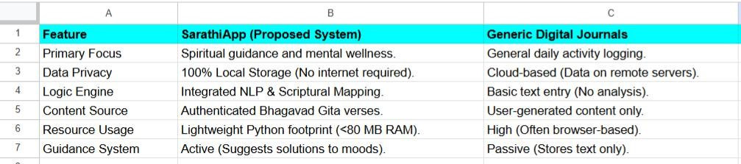
Table 6.1 USP of Bhagvad Mood Journal over Generic Digital Journals

Limitations

    - Platform Dependency: The current version is limited to desktop environments and lacks a mobile-responsive companion for on-the-go logging.
    - Language Constraint: The NLP sentiment analysis logic is currently optimized primarily for English, limiting its use for regional linguistic nuances.
    - Static Shloka Repository: The internal dataset contains a curated selection rather than the full philosophical depth of the entire Vedic corpus.
    - Manual Synchronization: There is no secure method for users to sync their data across multiple devices without manual database transfers.

Future Scope

    - Local LLM Integration: Implementing small-scale, offline Large Language Models to provide conversational spiritual guidance without sacrificing user privacy.
    - Cross-Platform Development: Expanding the codebase using Kivy or Flutter to support Android and iOS devices with end-to-end encrypted syncing.

    - Multi-Lingual Support: Adding support for Sanskrit-to-Hindi and other regional language translations to reach a broader demographic of users.
    - Predictive Analytics: Utilizing long-term mood data to identify emotional patterns and suggest proactive spiritual interventions before a crisis occurs.

REFERENCES
The following references include academic research, technical documentation, and existing platforms that informed the development and comparative analysis of the SarathiApp.

Academic & Philosophical References

- E. S. Rao and A. C. Paranjpe, "The Bhagavad Gita: A scriptural framework for psychological resilience and cognitive restructuring," Indian Journal of Psychological Medicine, vol. 38, no. 4, pp. 312-319, 2016.
- National Center for Biotechnology Information (NCBI), "The stress reduction potential of Bhagavad Gita and Yoga: A randomized controlled trial," PMC, 2026. [Online]. Available: https://www.ncbi.nlm.nih.gov/pmc/
- S. Sharma and G. Singh, "Spiritual Computing: Integrating Vedic wisdom into modern digital interfaces," International Journal of Computer Applications, vol. 174, no. 9, pp. 22-28, 2021.
- K. S. Rao, "Application of Nishkama Karma in modern stress management,"
Journal of Hindu Studies, vol. 12, no. 2, pp. 145-160, 2019.

- B. K. S. Iyengar, Light on Life: The Yoga Journey to Wholeness, Inner Peace, and Ultimate Freedom. New York: Rodale, 2005.

Technical & Software References

- Mozilla Foundation, "Privacy Not Included: A review of mental health app vulnerabilities," Mozilla Foundation Reports, 2024. [Online]. Available: https://foundation.mozilla.org/en/privacynotincluded/
- S. Lott, Mastering Object-Oriented Python: Build powerful and robust systems using the standard library. Birmingham, UK: Packt Publishing, 2021.

- Python Software Foundation, "Tkinter — Python interface to Tcl/Tk," Python
3.10.x Documentation, 2026. [Online]. Available: https://docs.python.org/3/library/tkinter.html
- SQLite Consortium, "SQLite: A self-contained, serverless, zero-configuration, transactional SQL database engine," 2026. [Online]. Available: https://www.sqlite.org/index.html
- S. Loria, "TextBlob: Simplified Text Processing," 2020. [Online]. Available: https://textblob.readthedocs.io/en/dev/

Comparative Study References (Applications & Platforms)

- Daylio, "Self-Care Bullet Journal with Goals & Mood Tracker," 2026. [Online]. Available: https://daylio.net/
- GitaGPT, "Interactive AI Spiritual Guide based on the Bhagavad Gita," 2025. [Online]. Available: https://gitagpt.org/
- Moodfit, "The #1 Mental Health App: Fitness for Your Mind," 2026. [Online]. Available: https://www.getmoodfit.com/
- Vedas AI, "Contextual Vedic Guidance for Modern Challenges," 2025. [Online]. Available: https://vedas.ai/
- Headspace Inc., "Mindfulness and Meditation for Stress Management," 2026. [Online]. Available: https://www.headspace.com/

APPENDIX

APPENDIX A: User Manual

Prerequisites

    - Python Installation: Ensure Python 3.x is installed on the local system.

    - Database Server: A local instance of MySQL Server must be active and accessible.
    - Environment Variables: The database password must be configured in the system environment variables as Chahat@2005@MySQL.
    - Library Dependencies: Install required packages including mysql-connector-python, textblob, tkcalendar, pillow, and matplotlib.

Running the Application

    - Database Setup: Verify that the MySQL service is running to allow the script to automatically generate the sarathi_sih_db database and required tables.
    - Asset Placement: Ensure BhagavadGita_Tri-lingual.pdf and gita_preview.png are located in the same directory as the main Python file.
    - Virtual Environment: Activate the project’s .venv to ensure all dependencies are correctly isolated and loaded.
    - Script Execution: Run the application using the command python SarathiApp.py.

    - Login/Registration: Use the "Register" frame for new accounts or "Login" for existing User, Admin, or Counselor credentials.
    - Corpora Download: Run python -m textblob.download_corpora if using the sentiment analysis feature for the first time.

Troubleshooting

    - Database Connection Error: Verify the MySQL credentials and ensure the environment variable password matches the root user password.
    - Missing Libraries: Run pip install -r requirements.txt to resolve any ImportError messages during startup.
    - Image/PDF Not Found: Check file naming conventions and directory paths if the Welcome Page or PDF viewer fails to load assets.

APPENDIX B: System Screenshots Description

    - Main Dashboard (Figure 5.1): Showcases the primary user interface featuring real-time mood tracking visualizations and navigation buttons.
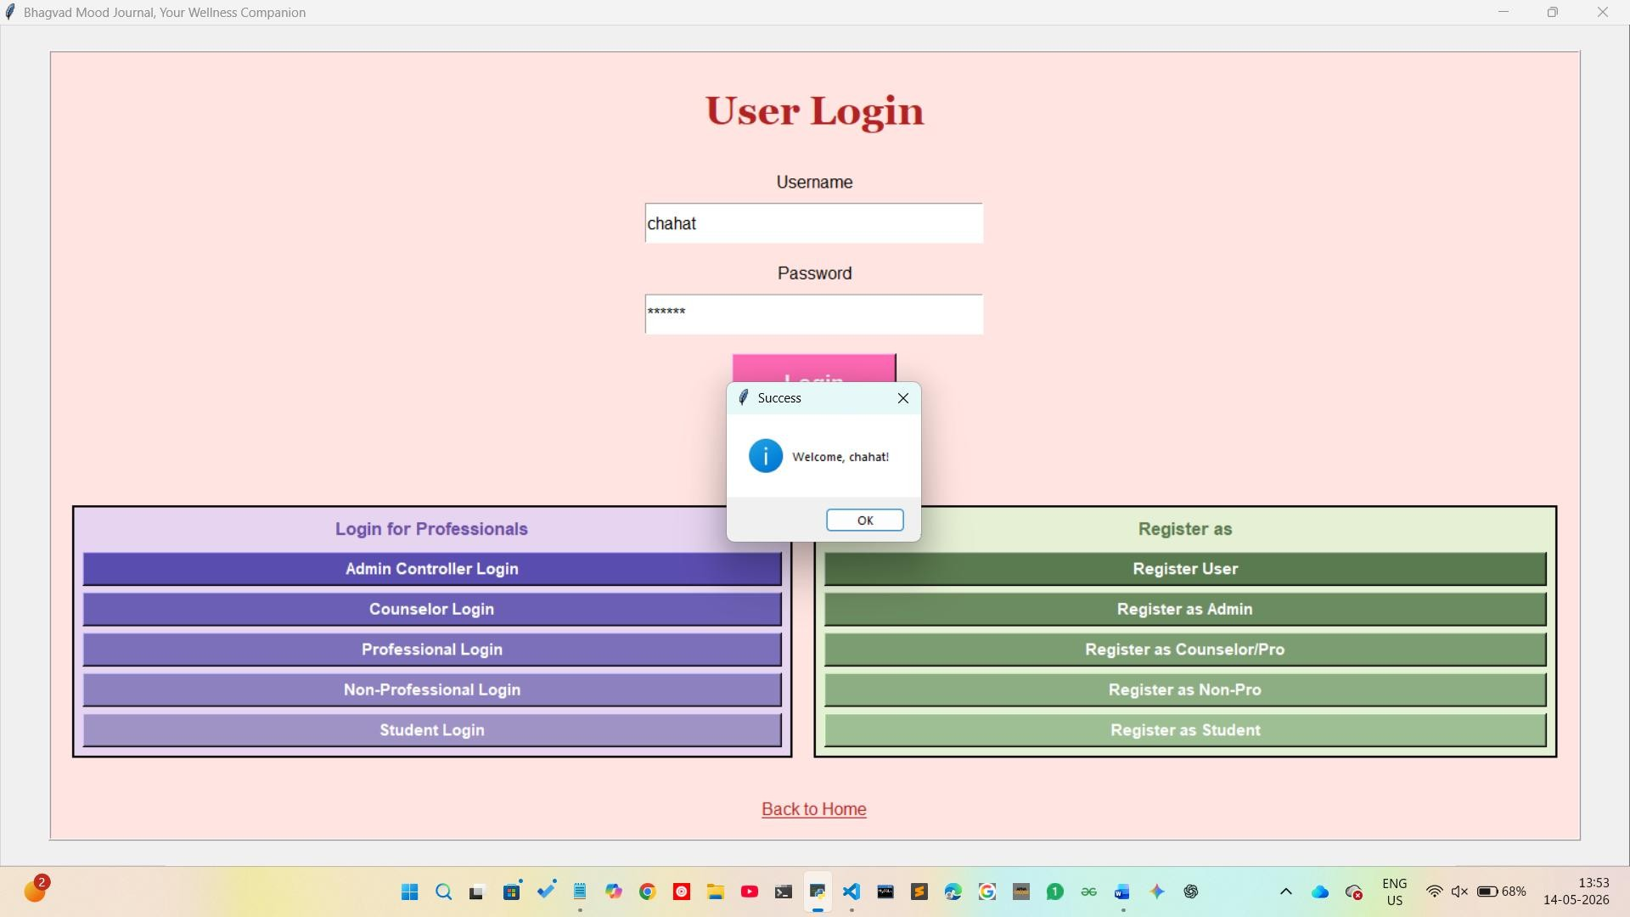

Figure 8: Main Dashboard – Displays the primary user login interface and navigation buttons for various system roles.

    - Journaling Module : Displays the text input area for thoughts alongside historical entries and generated spiritual insights.
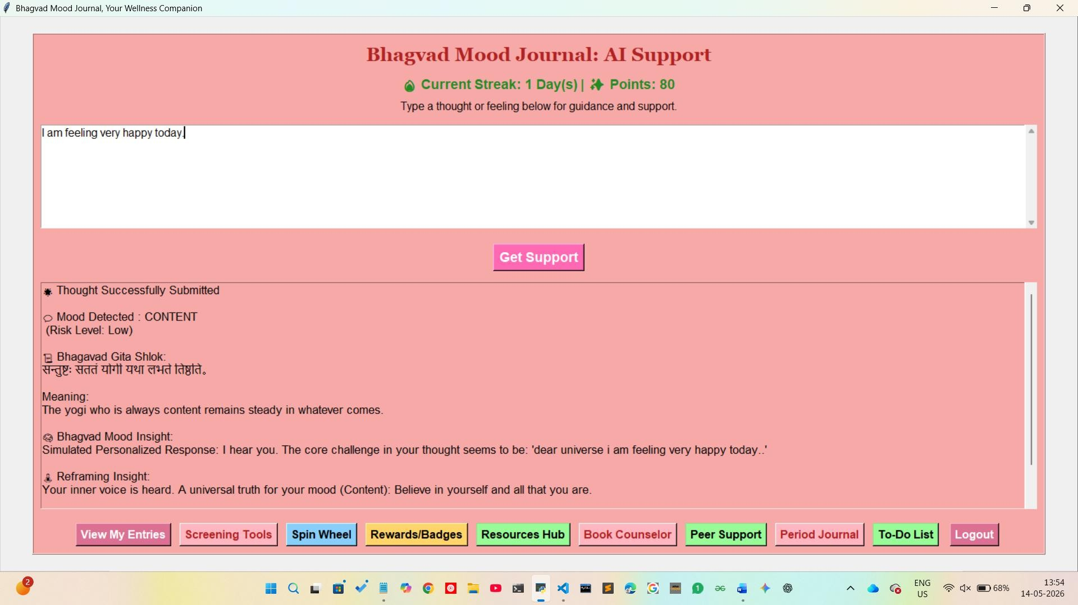

Figure 9: Journaling Module – Shows the AI-powered text input area for thoughts, including the generated spiritual insights and historical entry logs.

    - Counselor Portal: Illustrates the Clinical Context Dashboard where professionals view anonymized user emotional trends and manage bookings.
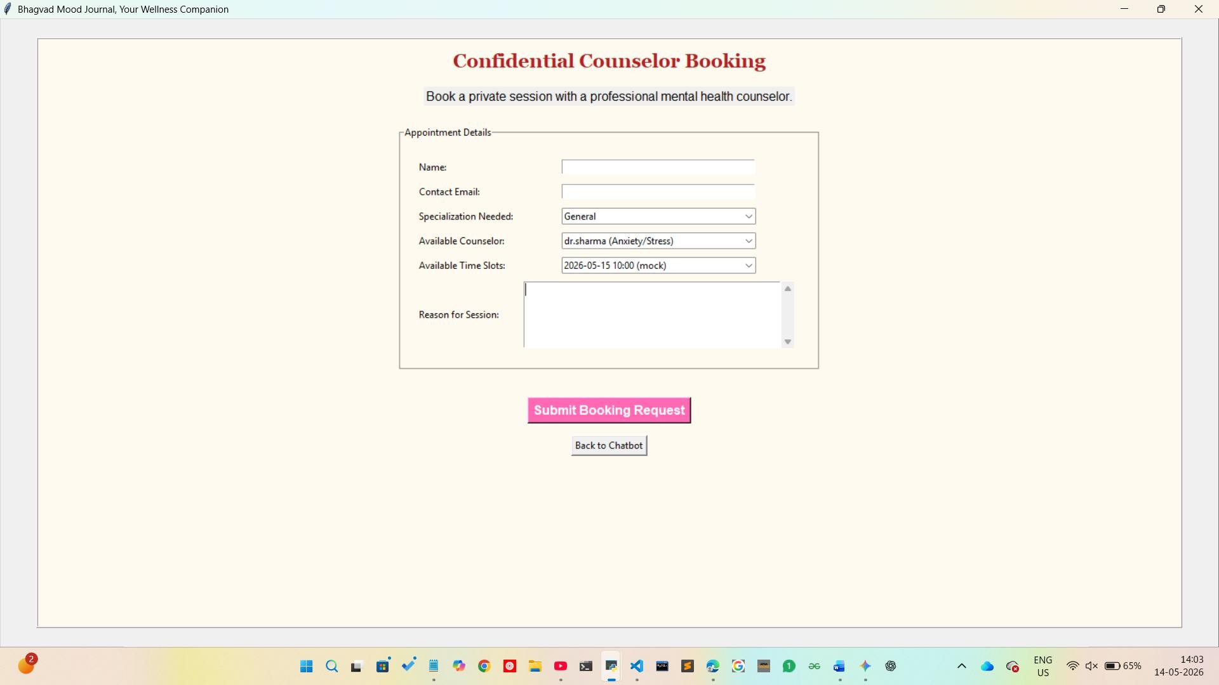

Figure 10: Counselor Portal – Illustrates the Confidential Counselor Booking dashboard used by professionals to manage user emotional trends and session bookings.

    - Period Journal Frame: Demonstrates the logging interface for physical symptoms, flow intensity, and energy levels.
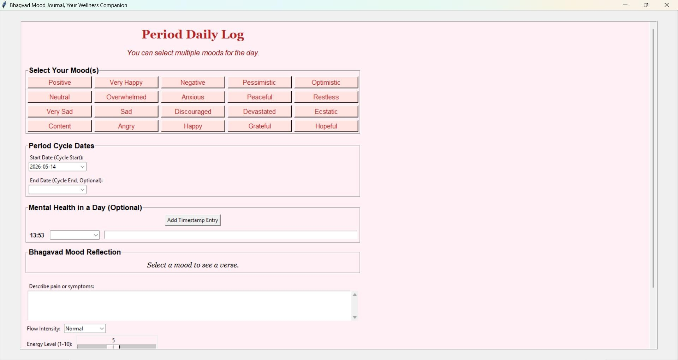

Figure 11: Period Daily Log – Demonstrates the "Period Journal Frame" interface for tracking physical symptoms, flow intensity, and energy levels.

    - Screening Tools: Shows the PHQ-9 and GAD-7 digital forms used for objective mental health assessment.
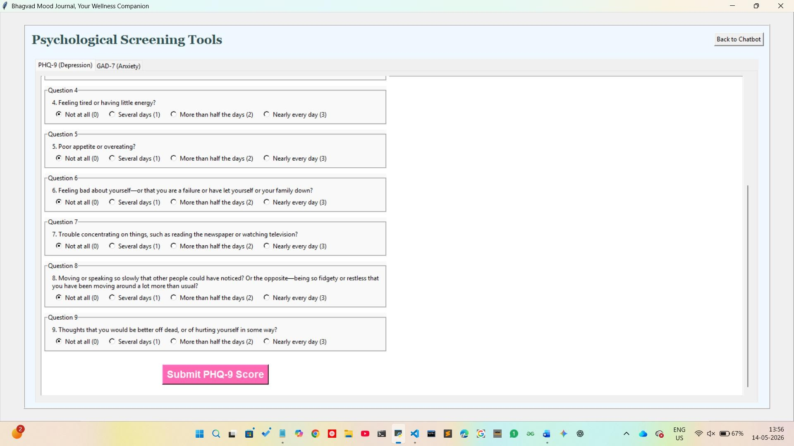

Figure 12: Psychological Screening Tools – Shows the digital assessment forms for objective mental health evaluation using PHQ-9 and GAD-7.

    - Gamified Rewards: Displays the badge collection and "Mindful Points" (MP) accumulation based on user activity.
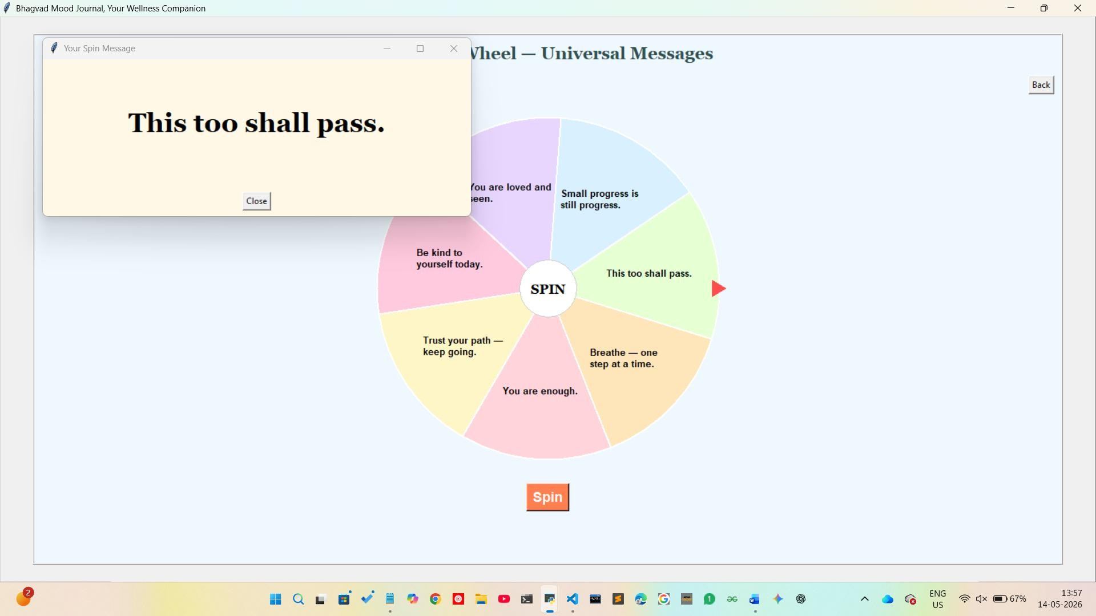

Figure 13: Gamified Rewards – Features the "Spin Wheel" for universal messages and the tracking system for user "Mindful Points" (MP) and badge collection.

APPENDIX C: Code (Optional)

    - Database Schema Logic: As shown in the DESCRIBE user_inputs output in Screenshot the schema utilizes an auto_increment primary key (id), a text field for user_text, and floating-point fields for polarity and subjectivity metrics. The timestamp field is set to CURRENT_TIMESTAMP to automatically log entry times. The accompanying SELECT query demonstrates that the database successfully stores qualitative text alongside classified mood_labels such as "Positive," "Neutral," or "Negative".
    - Sentiment Engine: Contains the get_sentiment_enhanced function utilizing TextBlob for polarity and subjectivity analysis.

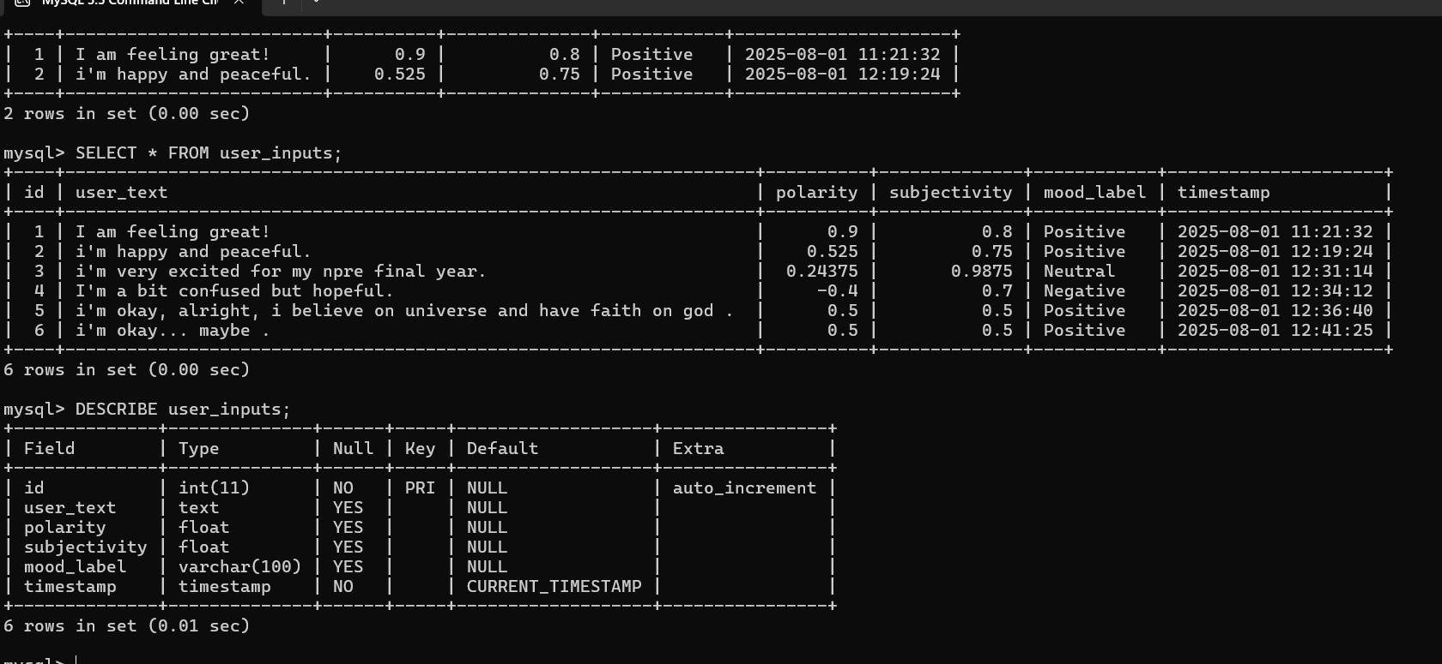

Figure 14: MySQL Schema for Sentiment Persistence and User Input Tracking.

      - Crisis Handling: Details the CRISIS_KEYWORDS regex list and the logic for redirecting users to emergency helplines.
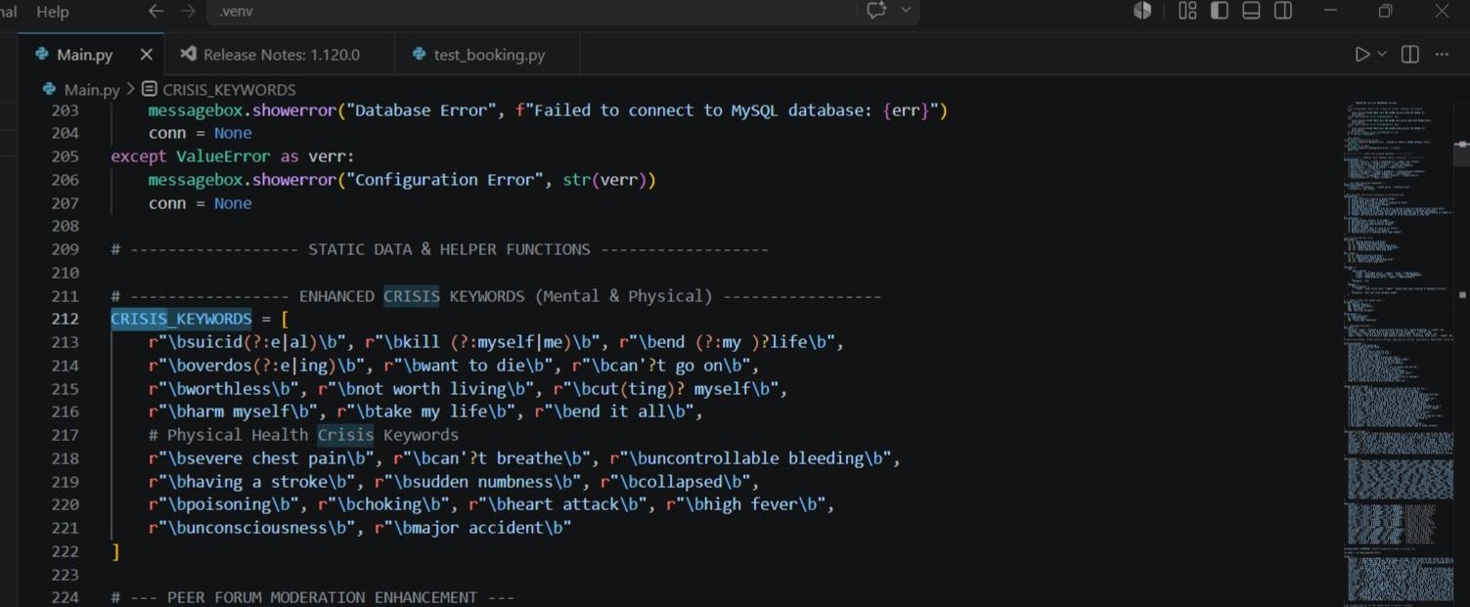

Figure 15: Crisis Detection Regex and Automated Intervention Logic

